1. **SPRING REST HANDSON**

**Hands on 1**

**Create a Spring Web Project using Maven**

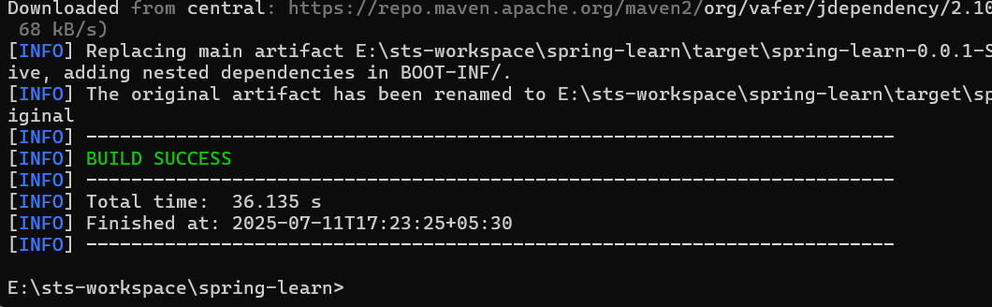

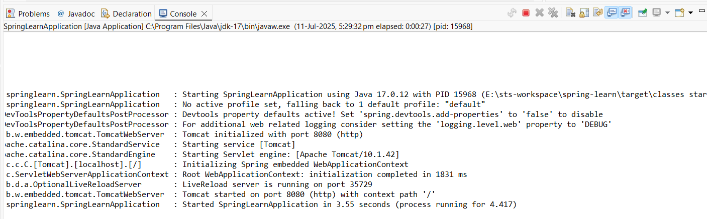

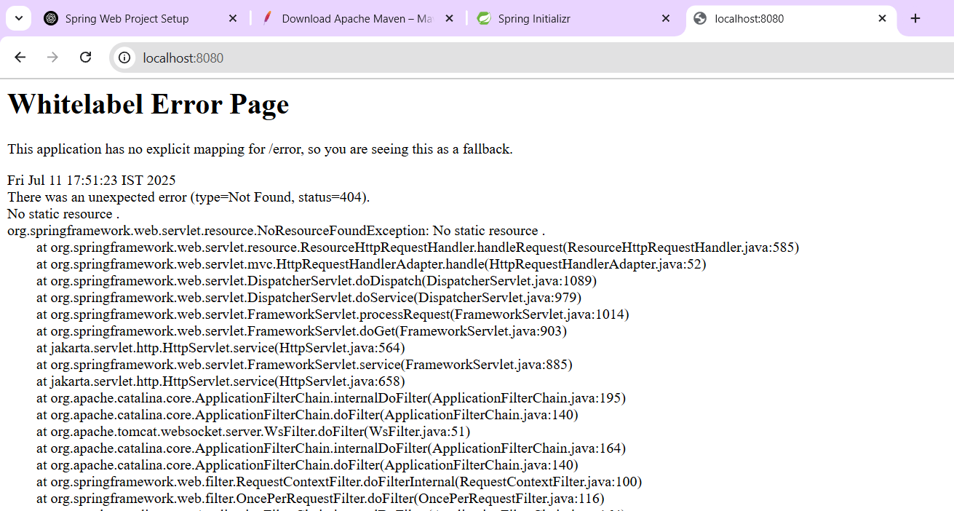

**Hands on 4**

**Spring Core – Load Country from Spring Configuration XML**

**File name: Country.java**

package com.cognizant.springlearn;

import org.slf4j.Logger;

import org.slf4j.LoggerFactory;

public class Country {

private static final Logger *LOGGER* = LoggerFactory.*getLogger*(Country.class);

private String code;

private String name;

public Country() {

*LOGGER*.debug("Inside Country Constructor.");

}

public String getCode() {

*LOGGER*.debug("Getting country code.");

return code;

}

public void setCode(String code) {

*LOGGER*.debug("Setting country code.");

this.code = code;

}

public String getName() {

*LOGGER*.debug("Getting country name.");

return name;

}

public void setName(String name) {

*LOGGER*.debug("Setting country name.");

this.name = name;

}

@Override

public String toString() {

return "Country [code=" + code + ", name=" + name + "]";

}

}

**File name: country.xml**

<?xml version="1.0" encoding="UTF-8"?>

<beans xmlns="http://www.springframework.org/schema/beans"

xmlns:xsi="http://www.w3.org/2001/XMLSchema-instance"

xsi:schemaLocation="

http://www.springframework.org/schema/beans

http://www.springframework.org/schema/beans/spring-beans.xsd">

<bean id="country" class="com.cognizant.springlearn.Country">

<property name="code" value="IN" />

<property name="name" value="India" />

</bean>

</beans>

**File name: Pom.xml**

<project xmlns="http://maven.apache.org/POM/4.0.0"

xmlns:xsi="http://www.w3.org/2001/XMLSchema-instance"

xsi:schemaLocation="

http://maven.apache.org/POM/4.0.0

http://maven.apache.org/xsd/maven-4.0.0.xsd">

<modelVersion>4.0.0</modelVersion>

<groupId>com.cognizant</groupId>

<artifactId>spring-learn</artifactId>

<version>0.0.1-SNAPSHOT</version>

<packaging>jar</packaging>

<name>spring-learn</name>

<properties>

<maven.compiler.source>17</maven.compiler.source>

<maven.compiler.target>17</maven.compiler.target>

<project.build.sourceEncoding>UTF-8</project.build.sourceEncoding>

</properties>

<dependencies>

<!-- Spring Core and Context -->

<dependency>

<groupId>org.springframework</groupId>

<artifactId>spring-context</artifactId>

<version>5.3.30</version>

</dependency>

<!-- SLF4J API for logging -->

<dependency>

<groupId>org.slf4j</groupId>

<artifactId>slf4j-api</artifactId>

<version>1.7.36</version>

</dependency>

<!-- Logback Classic for SLF4J implementation -->

<dependency>

<groupId>ch.qos.logback</groupId>

<artifactId>logback-classic</artifactId>

<version>1.2.11</version>

</dependency>

</dependencies>

</project>

**File name: SpringLearnApplication.java**

package com.cognizant.springlearn;

import org.slf4j.Logger;

import org.slf4j.LoggerFactory;

import org.springframework.context.ApplicationContext;

import org.springframework.context.support.ClassPathXmlApplicationContext;

public class SpringLearnApplication {

private static final Logger *LOGGER* = LoggerFactory.*getLogger*(SpringLearnApplication.class);

public static void main(String[] args) {

*LOGGER*.debug("START of main");

*displayCountry*();

*LOGGER*.debug("END of main");

}

public static void displayCountry() {

ApplicationContext context = new ClassPathXmlApplicationContext("country.xml");

Country country = context.getBean("country", Country.class);

*LOGGER*.debug("Country : {}", country.toString());

}

}

**OUTPUT**

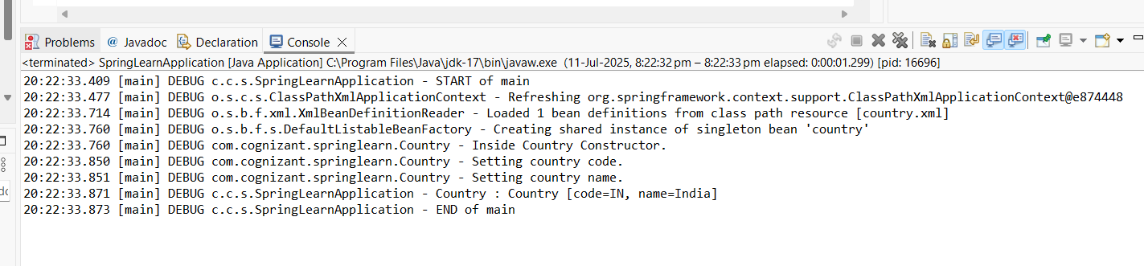

**<bean> Tag**

Defines a bean (object) in the Spring container.

<bean id="country" class="com.cognizant.springlearn.Country">

* id -- unique name for the bean in Spring
* class -- full-qualified class name to be instantiated

**<property> Tag**

Used to set values of the bean's fields via setter methods.

<property name="code" value="IN" />

* name matches the setter method name setCode()
* value is the string value passed

**ApplicationContext**

Interface that represents the Spring IoC (Inversion of Control) container.

It is responsible for:

* Loading bean definitions
* Instantiating and wiring beans
* Managing bean life cycle

**ClassPathXmlApplicationContext**

Implementation of ApplicationContext that loads context from an XML file located in the classpath.

ApplicationContext context = new ClassPathXmlApplicationContext("country.xml");

This line tells Spring to:

* Look for country.xml in the classpath
* Parse it
* Instantiate all <bean>s defined in it

**context.getBean("country", Country.class)**

This retrieves the bean named "country" of type Country.

Internally:

1. Spring looks for a bean with id="country"
2. Uses reflection to instantiate the class com.cognizant.springlearn.Country
3. Calls its constructor
4. Invokes setter methods (setCode, setName) with values from XML
5. Returns the fully initialized Country object
6. **SPRING REST HANDSON**

**Hello World RESTful Web Service**

**File name: HelloController.java**

package com.cognizant.springlearn.controller;

import org.slf4j.Logger;

import org.slf4j.LoggerFactory;

import org.springframework.web.bind.annotation.GetMapping;

import org.springframework.web.bind.annotation.RestController;

@RestController

public class HelloController {

private static final Logger *LOGGER* = LoggerFactory.*getLogger*(HelloController.class);

@GetMapping("/hello")

public String sayHello() {

*LOGGER*.info("START");

String response = "Hello World!!";

*LOGGER*.info("END");

return response;

}

}

**File name: SpringLearnApplication.java**

package com.cognizant.springlearn;

import org.slf4j.Logger;

import org.slf4j.LoggerFactory;

import org.springframework.boot.SpringApplication;

import org.springframework.boot.autoconfigure.SpringBootApplication;

@SpringBootApplication

public class SpringLearnApplication {

private static final Logger *LOGGER* = LoggerFactory.*getLogger*(SpringLearnApplication.class);

public static void main(String[] args) {

*LOGGER*.debug("START of main");

SpringApplication.*run*(SpringLearnApplication.class, args);

*LOGGER*.debug("END of main");

}

}

**Output:**

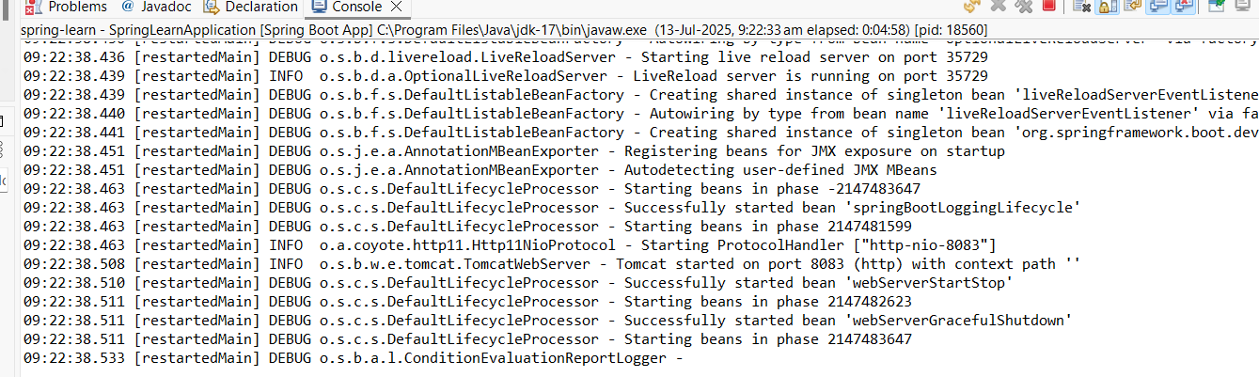

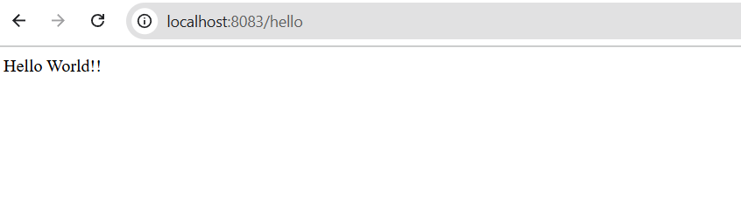

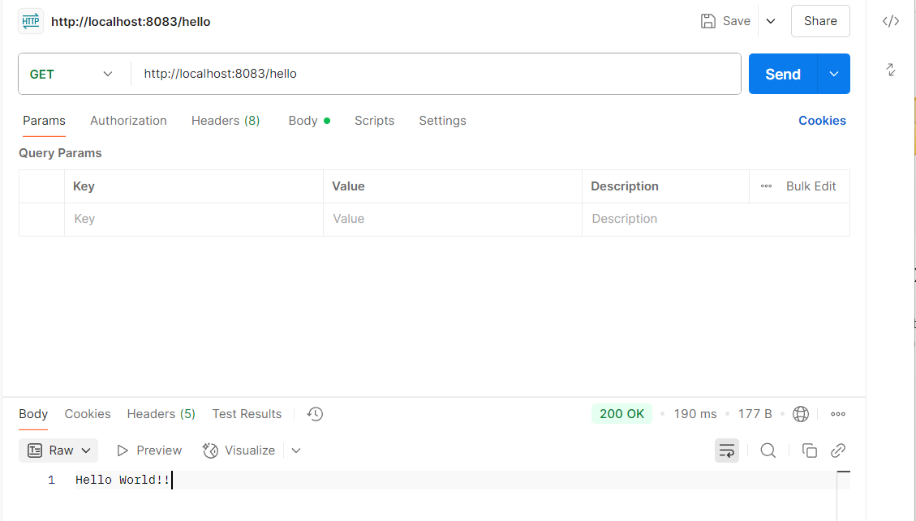

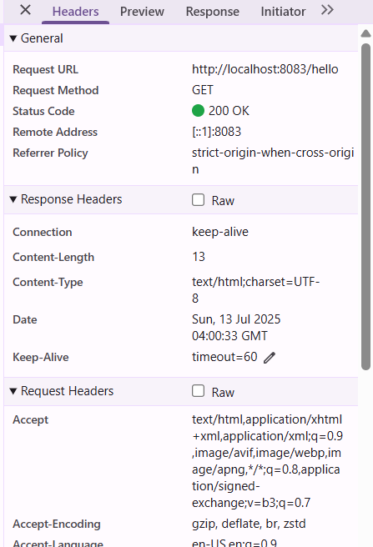

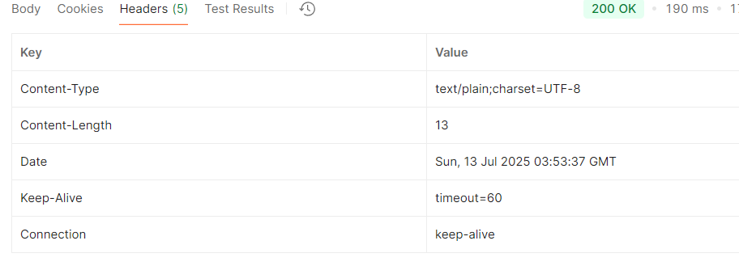

**REST - Country Web Service   
File name: SpringLearnApplication.java**

package com.cognizant.springlearn;

import org.slf4j.Logger;

import org.slf4j.LoggerFactory;

import org.springframework.boot.SpringApplication;

import org.springframework.boot.autoconfigure.SpringBootApplication;

@SpringBootApplication

public class SpringLearnApplication {

private static final Logger *LOGGER* = LoggerFactory.*getLogger*(SpringLearnApplication.class);

public static void main(String[] args) {

*LOGGER*.debug("START of main");

SpringApplication.*run*(SpringLearnApplication.class, args);

*LOGGER*.debug("END of main");

}

}

**File name: Country.java**

package com.cognizant.springlearn;

public class Country {

private String code;

private String name;

public Country() {

System.*out*.println("Inside Country Constructor.");

}

public String getCode() {

return code;

}

public void setCode(String code) {

System.*out*.println("Setting country code.");

this.code = code;

}

public String getName() {

return name;

}

public void setName(String name) {

System.*out*.println("Setting country name.");

this.name = name;

}

@Override

public String toString() {

return "Country [code=" + code + ", name=" + name + "]";

}

}

**File name:Country.xml**

<?xml version="1.0" encoding="UTF-8"?>

<beans xmlns="http://www.springframework.org/schema/beans"

xmlns:xsi="http://www.w3.org/2001/XMLSchema-instance"

xsi:schemaLocation="http://www.springframework.org/schema/beans

http://www.springframework.org/schema/beans/spring-beans.xsd">

<bean id="in" class="com.cognizant.springlearn.Country">

<property name="code" value="IN"/>

<property name="name" value="India"/>

</bean>

</beans>

**File name:CountryController.java**

package com.cognizant.springlearn.controller;

import com.cognizant.springlearn.Country;

import org.slf4j.Logger;

import org.slf4j.LoggerFactory;

import org.springframework.context.ApplicationContext;

import org.springframework.context.support.ClassPathXmlApplicationContext;

import org.springframework.web.bind.annotation.RequestMapping;

import org.springframework.web.bind.annotation.RestController;

@RestController

public class CountryController {

private static final Logger *LOGGER* = LoggerFactory.*getLogger*(CountryController.class);

@RequestMapping("/country")

public Country getCountryIndia() {

*LOGGER*.info("START");

ApplicationContext context = new ClassPathXmlApplicationContext("country.xml");

Country country = (Country) context.getBean("in");

*LOGGER*.info("END");

return country;

}

}

**OUTPUT:**

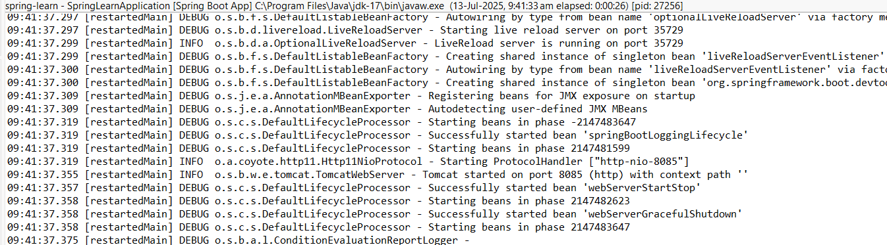

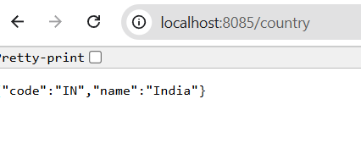 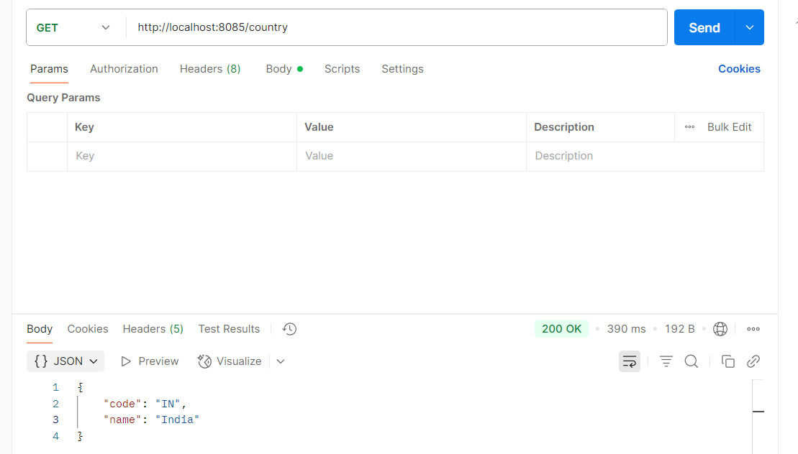

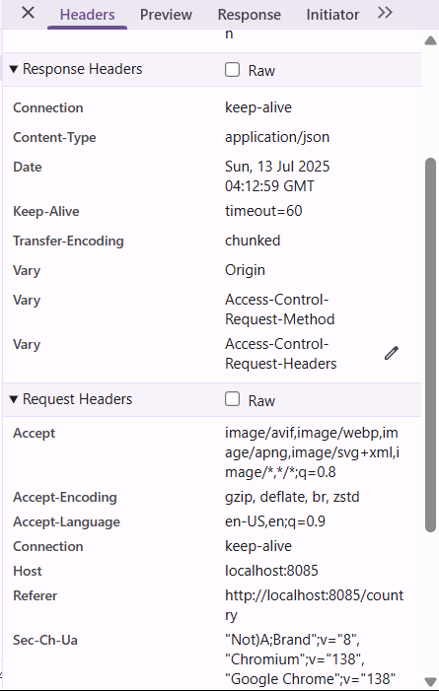

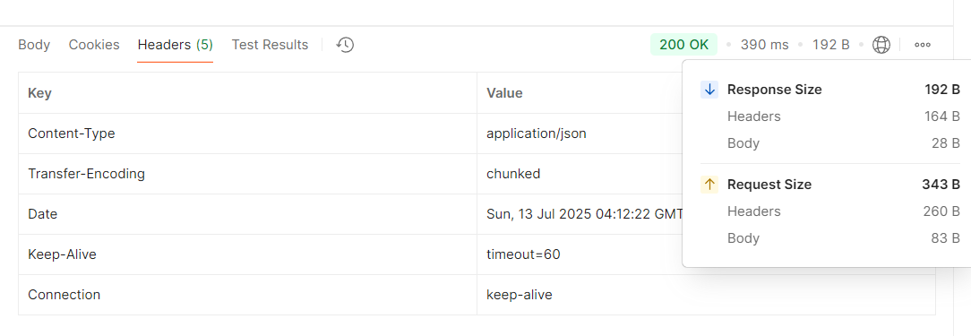

**What happens in the controller method?**

1. The controller receives a GET request on /country.
2. It logs START and loads Spring context from country.xml.
3. Retrieves the bean with id in — a Country object representing India.
4. Logs END and returns the bean as the HTTP response.

**How is the bean converted into JSON?**

* Spring Boot uses Jackson library (auto-included via spring-boot-starter-web) to convert Java objects (POJOs) into JSON format.
* The Country bean has getters, so Jackson serializes the object like this:

{ "code": "IN", "name": "India" }

* This is done automatically due to @RestController, which combines @Controller + @ResponseBody.

**REST - Get country based on country code**

**File name:Country.java**

package com.cognizant.springlearn;

public class Country {

private String code;

private String name;

public Country() {}

public String getCode() {

return code;

}

public void setCode(String code) {

this.code = code;

}

public String getName() {

return name;

}

public void setName(String name) {

this.name = name;

}

}

**File name:Country.xml**

<beans xmlns="http://www.springframework.org/schema/beans"

xmlns:xsi="http://www.w3.org/2001/XMLSchema-instance"

xsi:schemaLocation="http://www.springframework.org/schema/beans

http://www.springframework.org/schema/beans/spring-beans.xsd">

<bean id="in" class="com.cognizant.springlearn.Country">

<property name="code" value="IN"/>

<property name="name" value="India"/>

</bean>

<bean id="us" class="com.cognizant.springlearn.Country">

<property name="code" value="US"/>

<property name="name" value="United States"/>

</bean>

<bean id="countryList" class="java.util.ArrayList">

<constructor-arg>

<list>

<ref bean="in"/>

<ref bean="us"/>

</list>

</constructor-arg>

</bean>

</beans>

**File name:SpringLearnApplication.java**

package com.cognizant.springlearn;

import org.slf4j.Logger;

import org.slf4j.LoggerFactory;

import org.springframework.boot.SpringApplication;

import org.springframework.boot.autoconfigure.SpringBootApplication;

@SpringBootApplication

public class SpringLearnApplication {

private static final Logger *LOGGER* = LoggerFactory.*getLogger*(SpringLearnApplication.class);

public static void main(String[] args) {

*LOGGER*.debug("START of main");

SpringApplication.*run*(SpringLearnApplication.class, args);

*LOGGER*.debug("END of main");

}

}

**File name:CountryController.java**

package com.cognizant.springlearn.controller;

import com.cognizant.springlearn.Country;

import com.cognizant.springlearn.service.CountryService;

import org.slf4j.Logger;

import org.slf4j.LoggerFactory;

import org.springframework.beans.factory.annotation.Autowired;

import org.springframework.web.bind.annotation.*;

@RestController

public class CountryController {

private static final Logger *LOGGER* = LoggerFactory.*getLogger*(CountryController.class);

@Autowired

private CountryService countryService;

@GetMapping("/countries/{code}")

public Country getCountry(@PathVariable String code) {

*LOGGER*.info("START getCountry with code: {}", code);

Country result = countryService.getCountry(code);

*LOGGER*.info("END");

return result;

}

}

**File name:CountryService.java**

package com.cognizant.springlearn.service;

import com.cognizant.springlearn.Country;

import org.springframework.context.ApplicationContext;

import org.springframework.context.support.ClassPathXmlApplicationContext;

import org.springframework.stereotype.Service;

import java.util.List;

@Service

public class CountryService {

public Country getCountry(String code) {

ApplicationContext context = new ClassPathXmlApplicationContext("country.xml");

List<Country> countries = (List<Country>) context.getBean("countryList");

// Find country ignoring case

return countries.stream()

.filter(c -> c.getCode().equalsIgnoreCase(code))

.findFirst()

.orElse(null); // or throw new CountryNotFoundException(code);

}

}

**Output:**

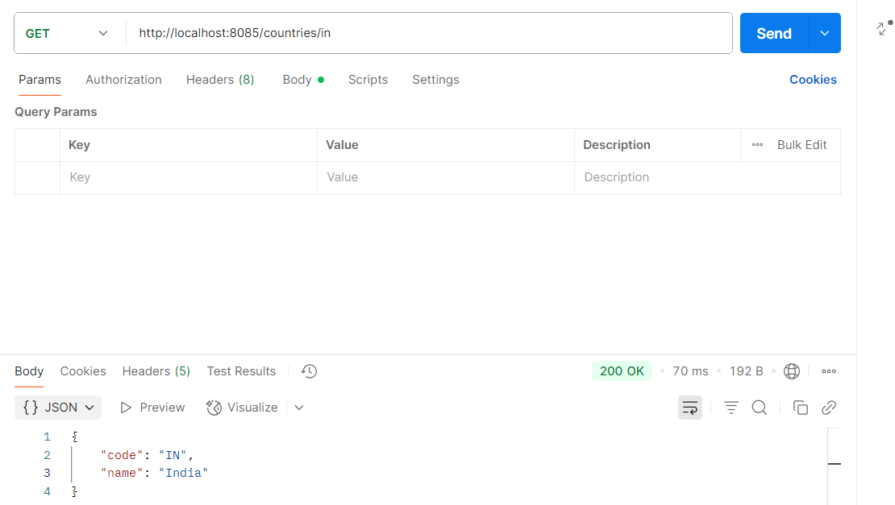

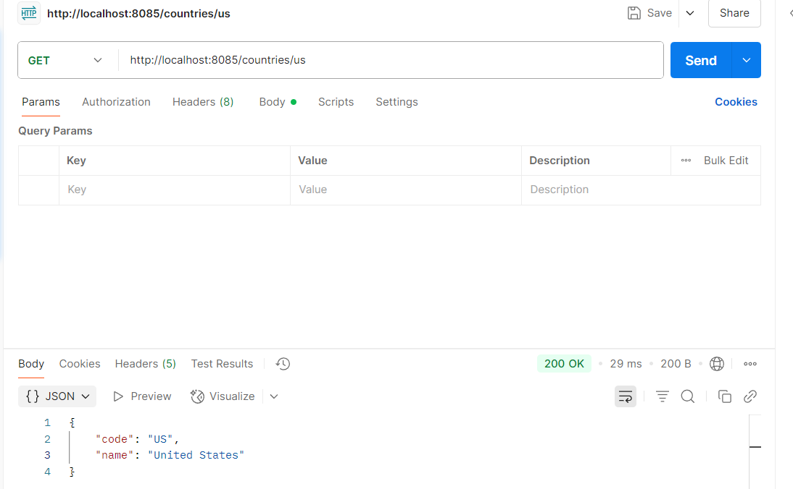

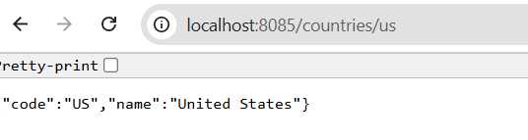

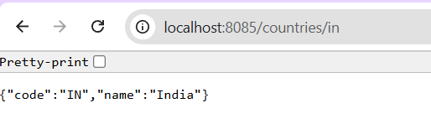

**What happens in the controller?**

* **Controller gets the {code} from the URL via @PathVariable**
* **It calls countryService.getCountry(code)**
* **The service fetches the countryList from Spring XML**
* **It performs a case-insensitive match and returns the matching country**

**How is the bean converted to JSON?**

* **Spring Boot uses Jackson (auto-configured with spring-boot-starter-web)**
* **Your Country class is a plain POJO with getters → automatically converted to JSON**

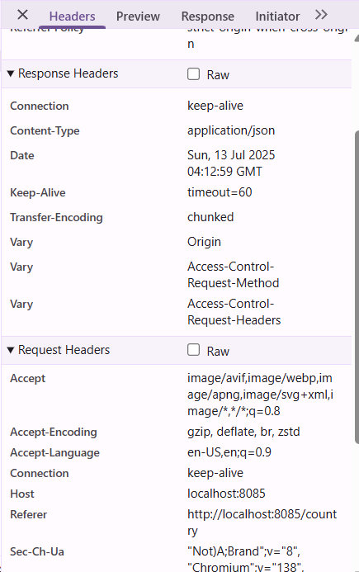

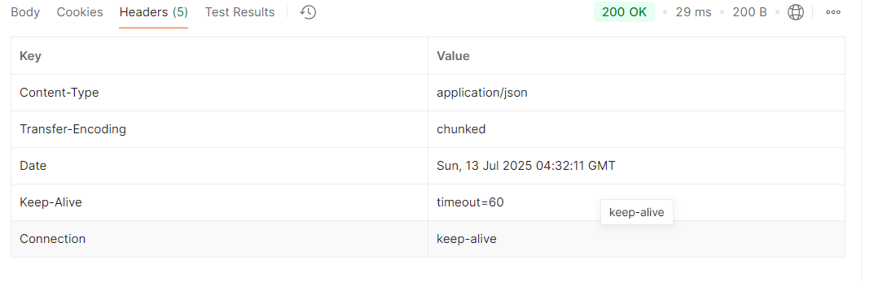

1. **JWT-handson**

**Create authentication service that returns JWT**

**Create authentication controller and configure it in SecurityConfig**

package com.cognizant.springlearn;

import org.springframework.boot.SpringApplication;

import org.springframework.boot.autoconfigure.SpringBootApplication;

@SpringBootApplication

public class SpringLearnApplication {

public static void main(String[] args) {

SpringApplication.*run*(SpringLearnApplication.class, args);

}

}

package com.cognizant.springlearn.config;

import org.springframework.context.annotation.Bean;

import org.springframework.context.annotation.Configuration;

import org.springframework.security.config.annotation.web.builders.HttpSecurity;

import org.springframework.security.core.userdetails.User;

import org.springframework.security.core.userdetails.UserDetails;

import org.springframework.security.provisioning.InMemoryUserDetailsManager;

import org.springframework.security.web.SecurityFilterChain;

@Configuration

public class SecurityConfig {

@Bean

public InMemoryUserDetailsManager userDetailsService() {

UserDetails user = User.*builder*()

.username("user")

.password("{noop}pwd") // {noop} = No password encoding

.roles("USER")

.build();

return new InMemoryUserDetailsManager(user);

}

@Bean

public SecurityFilterChain filterChain(HttpSecurity http) throws Exception {

http.csrf(csrf -> csrf.disable())

.authorizeHttpRequests(auth -> auth

.requestMatchers("/authenticate").permitAll()

.anyRequest().authenticated()

)

.httpBasic();

return http.build();

}

}

package com.cognizant.springlearn.controller;

import org.springframework.beans.factory.annotation.Autowired;

import org.springframework.http.ResponseEntity;

import org.springframework.web.bind.annotation.*;

import com.cognizant.springlearn.util.JwtUtil;

import java.util.Base64;

import jakarta.servlet.http.HttpServletRequest;

@RestController

public class AuthenticationController {

@Autowired

private JwtUtil jwtUtil;

@GetMapping("/authenticate")

public ResponseEntity<?> authenticate(HttpServletRequest request) {

// Extract Authorization header

String authHeader = request.getHeader("Authorization");

if (authHeader == null || !authHeader.startsWith("Basic ")) {

return ResponseEntity.*status*(401).body("Missing or invalid Authorization header");

}

// Decode Base64 credentials

String base64Credentials = authHeader.substring("Basic ".length());

String credentials = new String(Base64.*getDecoder*().decode(base64Credentials));

String[] values = credentials.split(":", 2);

String username = values[0];

String password = values[1];

System.*out*.println("🔐 Inside authenticate()");

// For demo: accept only hardcoded user/pwd

if ("user".equals(username) && "pwd".equals(password)) {

String token = jwtUtil.generateToken(username);

return ResponseEntity.*ok*().body("{\"token\":\"" + token + "\"}");

} else {

return ResponseEntity.*status*(403).body("Invalid credentials");

}

}

}

package com.cognizant.springlearn.util;

import io.jsonwebtoken.Jwts;

import io.jsonwebtoken.SignatureAlgorithm;

import io.jsonwebtoken.security.Keys;

import org.springframework.stereotype.Component;

import javax.crypto.SecretKey;

import java.util.Date;

@Component

public class JwtUtil {

private static final SecretKey *SECRET_KEY* = Keys.*secretKeyFor*(SignatureAlgorithm.*HS256*);

private static final long *EXPIRATION_TIME* = 1000 * 60 * 60; // 1 hour

public String generateToken(String username) {

return Jwts.*builder*()

.setSubject(username)

.setIssuedAt(new Date())

.setExpiration(new Date(System.*currentTimeMillis*() + *EXPIRATION_TIME*))

.signWith(*SECRET_KEY*)

.compact();

}

}

**OUTPUT**

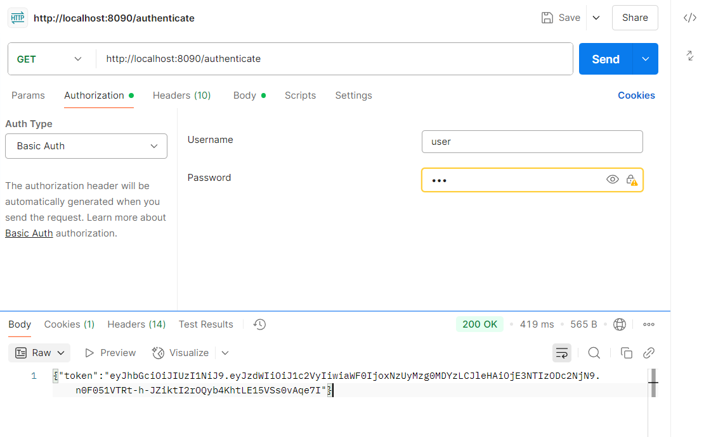

**Read Authorization header and decode the username and password**

**File name: AuthenticationController.java**

package com.cognizant.springlearn.controller;

import java.util.Base64;

import org.slf4j.Logger;

import org.slf4j.LoggerFactory;

import org.springframework.http.HttpHeaders;

import org.springframework.http.ResponseEntity;

import org.springframework.security.authentication.AuthenticationManager;

import org.springframework.security.authentication.UsernamePasswordAuthenticationToken;

import org.springframework.security.core.Authentication;

import org.springframework.security.core.AuthenticationException;

import org.springframework.web.bind.annotation.*;

import com.cognizant.springlearn.util.JwtUtil;

@RestController

public class AuthenticationController {

private static final Logger *LOGGER* = LoggerFactory.*getLogger*(AuthenticationController.class);

private final AuthenticationManager authenticationManager;

private final JwtUtil jwtUtil;

public AuthenticationController(AuthenticationManager authenticationManager, JwtUtil jwtUtil) {

this.authenticationManager = authenticationManager;

this.jwtUtil = jwtUtil;

}

@GetMapping("/authenticate")

public ResponseEntity<?> authenticate(@RequestHeader(HttpHeaders.*AUTHORIZATION*) String authHeader) {

*LOGGER*.debug("START of authenticate()");

String username = getUser(authHeader);

*LOGGER*.debug("Extracted Username: {}", username);

try {

// The actual authentication step (optional since JWT is already returned)

Authentication auth = new UsernamePasswordAuthenticationToken(username, "pwd");

authenticationManager.authenticate(auth);

} catch (AuthenticationException e) {

*LOGGER*.error("Authentication failed for user: {}", username);

return ResponseEntity.*status*(401).build();

}

String token = jwtUtil.generateToken(username);

*LOGGER*.debug("Generated JWT Token");

*LOGGER*.debug("END of authenticate()");

return ResponseEntity.*ok*().body("{\"token\":\"" + token + "\"}");

}

// 🔑 This is the method to decode and extract username from Base64 encoded Authorization header

private String getUser(String authHeader) {

*LOGGER*.debug("START of getUser()");

if (authHeader == null || !authHeader.startsWith("Basic ")) {

*LOGGER*.error("Invalid Authorization header: {}", authHeader);

return null;

}

String encodedCredentials = authHeader.substring("Basic ".length());

byte[] decodedBytes = Base64.*getDecoder*().decode(encodedCredentials);

String decodedCredentials = new String(decodedBytes); // will be user:pwd

*LOGGER*.debug("Decoded credentials: {}", decodedCredentials);

String username = decodedCredentials.split(":")[0];

*LOGGER*.debug("Extracted Username from Authorization header: {}", username);

*LOGGER*.debug("END of getUser()");

return username;

}

}

**OUTPUT:**

